CRIMINAL LAW PAPER · ISLAMABAD HIGH COURT · CIVIL JUDGE-CUM-MAGISTRATE EXAMINATION 2026
Topic 3 · Code of Criminal Procedure 1898
Definitions · criminal courts and their powers · Justices of the Peace · arrest · processes to compel appearance (summons, warrant, proclamation, attachment) · search · security and public-order proceedings · FIR and investigation · confessions · remand · cognizance and complaints · charge and joinder · trials (summary, Magistrate, Sessions) · examination of the accused · judgment · compounding · bail and bonds · appeals and revision · protections for women · juveniles
Knowledge Base — every concept in simple words, with rationale, cases, illustrations and maxims

Prepared for: Ihtisham Ul Haq (Roll No. 999)
Paper: Criminal Law (100 marks, 3 hours) — Pakistan Penal Code 1860, Code of Criminal Procedure 1898, Hudood Ordinances
This volume: Topic 3 of 4 — Code of Criminal Procedure 1898
Companion volumes: Topic 1 — PPC: general principles · Topic 2 — PPC: specific offences · Topic 4 — Hudood Ordinances
Text of the law used: Official text of the Code of Criminal Procedure (pakistancode.gov.pk), including the 2016 anti-rape and honour amendments, Act XXXIII of 2022 (bank guarantee), and Act XXXVI of 2026 (s. 514, ICT only); Juvenile Justice System Act 2018

Contents
How to use this knowledge base 4
What Topic 3 covers 4
How the exam asks this topic 4
Chapter 1 · The scheme of the Code and key definitions 6
1.1 Nature of the Code 6
1.2 The core definitions — s. 4 6
1.3 Classic distinctions (LHC 2023) 6
Chapter 2 · Criminal courts and their powers 8
2.1 Classes of criminal courts — s. 6 (LHC 2023) 8
2.2 Sentences which courts may pass — ss. 31 to 35 (LHC 2023) 8
2.3 Justices of the Peace — ss. 22A, 22B, 25 9
Chapter 3 · Arrest (ss. 46 to 67) 10
3.1 How an arrest is made — ss. 46 to 53 10
3.2 Arrest without warrant by the police — s. 54 10
3.3 Arrest by a private person — s. 59 (LHC 2023) 10
3.4 Production within 24 hours — ss. 60, 61 (LHC 2023) 10
3.5 Other rules 11
Chapter 4 · Processes to compel appearance (ss. 68 to 93) — KPHC 2026; LHC 2023 12
4.1 Summons — ss. 68 to 74 12
4.2 Warrant of arrest — ss. 75 to 86 12
4.3 Proclamation for a person absconding — s. 87 (LHC 2020, 2023; ASJ 2025) 13
4.4 Attachment of property — s. 88 13
4.5 Restoration of attached property — s. 89 and the appeal under s. 405 13
4.6 Consequences of being a proclaimed offender (ASJ 2025; SHC 2022) 14
4.7 Bonds for appearance — ss. 91 to 93 14
Chapter 5 · Search and seizure 15
5.1 Search warrants — when issued (LHC 2023) 15
5.2 General rules of search 15
Chapter 6 · Prevention of offences and public order (ss. 106 to 148) 16
6.1 Security proceedings 16
6.2 Nuisance, urgent orders and land disputes 16
Chapter 7 · Information to the police and investigation (ss. 154 to 176) 17
7.1 First Information Report — s. 154 17
7.2 Non-cognizable cases — s. 155 18
7.3 Investigation — ss. 156 to 160 18
7.4 Statements of witnesses — ss. 161, 162 (LHC 2023) 18
7.5 Confessions — s. 164 (LHC 2023) 18
7.6 Medical examination and DNA — ss. 164A, 164B (2016) 19
7.7 Remand — s. 167 and s. 344 (LHC 2023) 19
7.8 Release and report — ss. 169 to 173 20
7.9 Inquest, burns, death in custody — ss. 174 to 176 (LHC 2023) 20
7.10 Remedies of a complainant when the police are protecting the accused (ASJ 2025) 20
Chapter 8 · Cognizance and complaints (ss. 190 to 205) 22
8.1 Cognizance by Magistrates — s. 190 22
8.2 Bars to cognizance — ss. 195 to 199 22
8.3 Complaints to Magistrates — ss. 200 to 205 22
Chapter 9 · The charge (ss. 221 to 240) — KPHC 2026; ASJ 2025; SHC 2022 24
9.1 Purpose 24
9.2 Contents of a charge — ss. 221 to 224 24
9.3 Effect of errors, alteration — ss. 225 to 232 24
9.4 Joinder of charges — ss. 233 to 240 24
9.5 Misjoinder and non-joinder — impact on the trial 25
9.6 How to frame a charge (model) 26
Chapter 10 · Trials 27
10.1 Summary trials — ss. 260 to 265 27
10.2 Trials before Magistrates — ss. 241 to 250 27
10.3 Trials before High Courts and Courts of Session — ss. 265A to 265N 28
10.4 Examination of the accused — s. 342 (LHC 2023) 28
10.5 Recording evidence in the absence of the accused — s. 512 (LHC 2023) 29
10.6 Death of an accused during trial (LHC 2023) 29
10.7 Other general provisions 29
10.8 Identification parade (SHC 2022) 30
10.9 Judgment — ss. 366 to 373 30
Chapter 11 · Bail (ss. 496 to 498A) — KPHC 2026; ASJ 2025 31
11.1 Meaning and philosophy 31
11.2 Bailable offences — s. 496 31
11.3 Non-bailable offences — s. 497 31
11.4 "Reasonable grounds" and "further inquiry" (ASJ 2025) 32
11.5 Concurrent powers and pre-arrest bail — ss. 498, 498A 32
11.6 Bail pending appeal — s. 426 33
11.7 Bonds and sureties — ss. 499 to 502 33
11.8 Termination of bail (KPHC 2026) 33
11.9 Deposit, forfeiture and appeal — ss. 513 to 516 (LHC 2020) 33
11.10 Bail in a s. 489F case — model order outline (SHC 2022) 34
Chapter 12 · Appeals, revision and inherent powers 35
12.1 Appeals — the scheme 35
12.2 Cases in which no appeal lies — ss. 412 to 415 (LHC 2020) 35
12.3 Procedure in appeal — ss. 419 to 431 35
12.4 Revision — ss. 435 to 439A 35
12.5 Inherent powers — s. 561A 36
12.6 Transfer — ss. 526, 528 36
Chapter 13 · Protections for women in arrest, investigation and trial (KPHC 2026) 37
Chapter 14 · Juvenile Justice System Act 2018 (in brief) 38
Chapter 15 · Maxims and last-night revision 39
15.1 Maxims 39
15.2 The 30 points of Topic 3 40
zzTOCENDzz

How to use this knowledge base

What Topic 3 covers
- Definitions and the classification of offences (s. 4; Schedule II).
- Criminal courts — classes, sentencing powers (ss. 6–35), Justices of the Peace (ss. 22A–25).
- Arrest (ss. 46–67) and processes to compel appearance — summons, warrant, proclamation and attachment (ss. 68–93).
- Search (ss. 96–105, 165) and preventive proceedings — security, nuisance, s. 144, s. 145 (ss. 106–148).
- Investigation — FIR (s. 154), statements (ss. 161–162), confessions (s. 164), remand (s. 167), report (s. 173).
- Cognizance, complaints, and the charge (ss. 190–240).
- Trials — summary, before Magistrates and before Courts of Session; s. 342; judgment; compounding (ss. 241–382B).
- Bail and bonds (ss. 496–516A) and appeals, revision, inherent powers (ss. 404–439A, 561A).
- Protections for women and the Juvenile Justice System Act 2018.
ISLAMABAD-SPECIFIC LAW · In the Islamabad Capital Territory
- Magistrates are Judicial Magistrates (Civil Judges-cum-Judicial Magistrates) appointed under the separation of the judiciary from the executive; executive functions (ss. 107–144) are performed by Executive Magistrates under the ICT administration.
- The Sessions Judge and, on his nomination, the Additional Sessions Judges are ex-officio Justices of the Peace (s. 25) and hear petitions under s. 22A(6).
- Act XXXVI of 2026 (ICT only) allows a forfeited bond to be recovered from immovable as well as movable property (s. 514(2)) and limits remission to not more than half of the surety amount (s. 514(5)).
- Act XXXIII of 2022 lets a person required to execute a bond furnish a bank guarantee instead (s. 513).
- The Islamabad High Court exercises the High Court's criminal powers in the ICT.

How the exam asks this topic
Paper | What it asked
KP High Court, Criminal Law, 2026 | Framing of charge, joinder, misjoinder and non-joinder; protections for women in arrest, investigation and trial; processes to compel appearance; bail — its forms and termination
LHC ASJ, Criminal Law-II, 2025 | Frame charges on a set of facts; principles of pre-arrest and post-arrest bail, "reasonable grounds" and "further inquiry"; proclaimed offender applying for pre-arrest bail; diversion under the JJSA 2018; remedies of a complainant whose case the police are spoiling
LHC Civil Judge, Criminal Law, 2023 | Classes of courts; sentences Magistrates may pass; modes of compelling attendance; proclamation; arrest by private person; 24-hour production; search warrants; joinder of charges; death of accused during trial; recording a confession; s. 342; evidence in the absence of the accused; cognizable offence vs cognizable case; ss. 161 and 162; physical vs judicial remand; complaint case vs State case; bailable vs non-bailable; juvenile age determination and joint trial; death in police custody
LHC Civil Judge, Criminal Law, 2020 | Proclamation and attachment and restoration of property; deposit in lieu of bond; forfeiture of bonds and the appeal under s. 515; cases where no appeal lies and s. 415; JJSA ss. 14–16 and definitions
Sindh High Court, 2022 | Bail order in a s. 489F case; proclaimed offender; identification parade; contents of a charge and joinder; cases where a Magistrate may acquit

Chapter 1 · The scheme of the Code and key definitions

1.1 Nature of the Code
The CrPC is a procedural law: it lays down the machinery for investigating offences, bringing offenders to court, trying them, and executing sentences. All PPC offences are dealt with under it (s. 5(1)); offences under other laws too, subject to any special procedure in those laws (s. 5(2)) — e.g., the Anti-Terrorism Act 1997, the CNSA 1997, the Juvenile Justice System Act 2018. Procedure is the handmaid of justice: an irregularity does not vitiate proceedings unless it has caused a failure of justice (s. 537).

1.2 The core definitions — s. 4
Term | Meaning
Bailable / non-bailable offence (s. 4(1)(b)) | An offence shown as bailable in the Second Schedule or made bailable by another law; every other offence is non-bailable
Cognizable offence / case (s. 4(1)(f)) | An offence for which, and a case in which, a police officer may arrest without warrant under the Second Schedule or any other law
Non-cognizable offence / case (s. 4(1)(n)) | One in which the police may not arrest without warrant
Complaint (s. 4(1)(h)) | An allegation, oral or written, made to a Magistrate with a view to his taking action, that some person (known or unknown) has committed an offence — but not a police report
Inquiry (s. 4(1)(k)) | Every inquiry other than a trial conducted by a Magistrate or Court (e.g., ss. 107, 145, 176, 202, 476)
Investigation (s. 4(1)(l)) | All proceedings for the collection of evidence by a police officer or a person (other than a Magistrate) authorised by a Magistrate
Offence (s. 4(1)(o)) | Any act or omission made punishable by any law
Officer in charge of a police station (s. 4(1)(p)) | Includes the next senior officer above constable present when the SHO is absent
Police report | The report forwarded under s. 173 (challan)

1.3 Classic distinctions (LHC 2023)
Pair | First | Second
Cognizable offence / cognizable case | The offence itself, as classified in Schedule II (e.g., theft, s. 379) | The case as a whole — a case is cognizable if the police may arrest without warrant in it; a case containing both cognizable and non-cognizable offences is treated as cognizable for investigation (s. 155(4) principle)
Bailable / non-bailable offence | Bail is a right — the officer or court shall release (s. 496) | Bail is a discretion — "may" release, but not where reasonable grounds exist of an offence in the prohibitory clause (s. 497)
Complaint case / State case | Begun by a complaint to a Magistrate (s. 200); complainant leads evidence; may be withdrawn (s. 248) or dismissed for non-appearance (s. 247) | Begun on a police report (s. 173) after an FIR; the State prosecutes through the Public Prosecutor; withdrawal only under s. 494
Inquiry / investigation / trial | Inquiry — by a Magistrate or court, short of a trial | Investigation — by police, to collect evidence; trial — the judicial determination of guilt, beginning with the charge
Discharge / acquittal | Release before the charge (e.g., s. 494(a)); no bar to a fresh case | Finding of not guilty after the charge; bars a second trial (s. 403)

Chapter 2 · Criminal courts and their powers

2.1 Classes of criminal courts — s. 6 (LHC 2023)
Besides the High Court and courts under special laws (Anti-Terrorism Courts, Special Courts, Juvenile Courts, Banking Courts), there are two classes of criminal courts:
- Courts of Session — the Sessions Judge, Additional Sessions Judges and Assistant Sessions Judges (s. 9);
- Courts of Magistrates — Magistrates of the first, second and third class (s. 6(2)), with s. 30 Magistrates (first-class Magistrates specially empowered to try all offences not punishable with death).
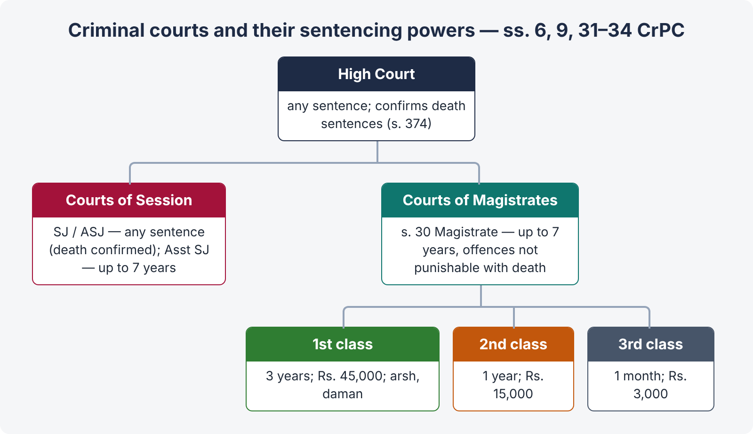
Figure 1 · Criminal courts and their sentencing powers

2.2 Sentences which courts may pass — ss. 31 to 35 (LHC 2023)
Court | Sentence it may pass
High Court (s. 31(1)) | Any sentence authorised by law
Sessions Judge / Additional Sessions Judge (s. 31(2)) | Any sentence authorised by law — death subject to confirmation by the High Court (s. 374)
Assistant Sessions Judge (s. 31(3)) | Any sentence except death or imprisonment exceeding seven years
Section 30 Magistrate (s. 34) | Any sentence except death or imprisonment exceeding seven years
Magistrate of the first class (s. 32(1)(a)) | Imprisonment up to three years (including solitary confinement allowed by law); fine up to Rs. 45,000; arsh; daman; whipping
Magistrate of the second class (s. 32(1)(b)) | Imprisonment up to one year; fine up to Rs. 15,000
Magistrate of the third class (s. 32(1)(c)) | Imprisonment up to one month; fine up to Rs. 3,000

Default imprisonment (s. 33) — within the Magistrate's powers, and where substantive imprisonment is awarded, not more than one-fourth of his maximum; it may be in addition to the maximum substantive sentence. Several offences at one trial (s. 35) — consecutive unless ordered concurrent; total not more than 14 years, and for a Magistrate not more than twice his ordinary powers.

2.3 Justices of the Peace — ss. 22A, 22B, 25
- Powers (s. 22A): to arrest as a police officer (ss. 54, 55) and hand the person to the SHO, who re-arrests; to call on police on duty to aid in arresting offenders and preventing crime; to issue identity certificates, verify and attest documents.
- Ex-officio Justices of the Peace (s. 25): the Sessions Judges and, on nomination by them, the Additional Sessions Judges, for the whole district.
- Directions to the police — s. 22A(6): an ex-officio Justice of the Peace may issue appropriate directions to the police on a complaint regarding (i) non-registration of a criminal case; (ii) transfer of investigation from one police officer to another; and (iii) neglect, failure or excess committed by a police authority in its functions and duties.
- Duties (s. 22B): inquire into and report breaches of the peace and offences to the nearest Magistrate and SHO; preserve the scene of a cognizable offence; assist an investigating officer on written request, and record a dying declaration.
CASE STUDY · Khizar Hayat v. Inspector-General of Police (PLD 2005 Lahore 470) and Younas Abbas v. Additional Sessions Judge (PLD 2016 SC 581)
The functions of the ex-officio Justice of the Peace under s. 22A(6) are quasi-judicial, not executive or ministerial — so they are not an investigating or supervisory agency. Younas Abbas (larger bench) confirmed that these functions are quasi-judicial, and the Justice of the Peace must hear both sides and pass a reasoned order. On a petition for registration of an FIR, he examines whether the information discloses a cognizable offence; if so, the SHO is bound to register it (s. 154) — the police cannot hold a "preliminary inquiry" first.

Chapter 3 · Arrest (ss. 46 to 67)

3.1 How an arrest is made — ss. 46 to 53
- s. 46 — by touching or confining the body, unless the person submits by word or action; if he resists or tries to evade, all means necessary may be used — but this does not give a right to cause the death of a person not accused of an offence punishable with death or imprisonment for life.
- s. 47 — the police may search a place entered by the person to be arrested; if the place is an apartment in the actual occupancy of a woman (not the person to be arrested) who by custom does not appear in public, she must be given notice and every facility to withdraw before entry.
- s. 48 — break open outer or inner doors or windows if refused admittance.
- ss. 49, 50 — no more restraint than necessary to prevent escape.
- s. 51 — search of the arrested person; seized articles listed.
- s. 52 — "Whenever it is necessary to cause a woman to be searched, the search shall be made by another woman, with strict regard to decency."
- s. 53 — seizure of offensive weapons.

3.2 Arrest without warrant by the police — s. 54
A police officer may arrest without warrant (nine heads): (1) a person concerned in a cognizable offence, or against whom a reasonable complaint, credible information or reasonable suspicion exists; (2) one possessing a house-breaking implement without lawful excuse; (3) a proclaimed offender; (4) one in possession of property reasonably suspected stolen; (5) one who obstructs a police officer or escapes from lawful custody; (6) a suspected deserter from the armed forces; (7) one concerned in an act abroad which would be an offence here (extradition); (8) a released convict breaking a rule under s. 565(3); (9) on requisition from another police officer. Also s. 55 (vagabonds, habitual robbers), s. 56 (written order to a subordinate), s. 57 (refusal to give name and residence in a non-cognizable case).

3.3 Arrest by a private person — s. 59 (LHC 2023)
- Who may be arrested: any person who in his view commits a non-bailable and cognizable offence, or any proclaimed offender.
- Procedure: without unnecessary delay, make him over to a police officer, or, in the absence of one, take him to the nearest police station.
- If he falls under s. 54, the police re-arrest him; if he has committed a non-cognizable offence and refuses his name and residence, he is dealt with under s. 57; if there is no reason to believe he committed any offence, he is released at once.

3.4 Production within 24 hours — ss. 60, 61 (LHC 2023)
- s. 60 — a police officer arresting without warrant shall, without unnecessary delay, take the person before a Magistrate having jurisdiction or the officer in charge of a police station.
- s. 61 — no police officer shall detain a person arrested without warrant for longer than is reasonable, and the period shall not exceed twenty-four hours, exclusive of the time necessary for the journey from the place of arrest to the Magistrate's court, in the absence of a special order of a Magistrate under s. 167.
- Constitutional guarantee — Art. 10: an arrested person must be informed of the grounds, has the right to consult and be defended by a legal practitioner of his choice, and must be produced before a Magistrate within 24 hours.
Consequences of failure: the detention becomes illegal; the arrested person may seek release through a habeas corpus petition (Art. 199; CrPC s. 491) or a search warrant under s. 100 to recover him from illegal confinement; the officers are liable for wrongful confinement (PPC ss. 342–348) and departmental action (Police Order 2002); evidence obtained by torture is excluded (Art. 14(2) — no torture for extracting evidence; QSO Art. 38–39 for confessions to police).

3.5 Other rules
- s. 62 — the SHO reports arrests without warrant to the district police and authorities.
- s. 63 — an arrested person is discharged only on his bond, bail or a Magistrate's special order.
- ss. 64, 65 — a Magistrate may arrest, or order the arrest of, an offender committing an offence in his presence.
- s. 66 — a person escaping may be pursued and re-arrested anywhere in Pakistan.

Chapter 4 · Processes to compel appearance (ss. 68 to 93) — KPHC 2026; LHC 2023
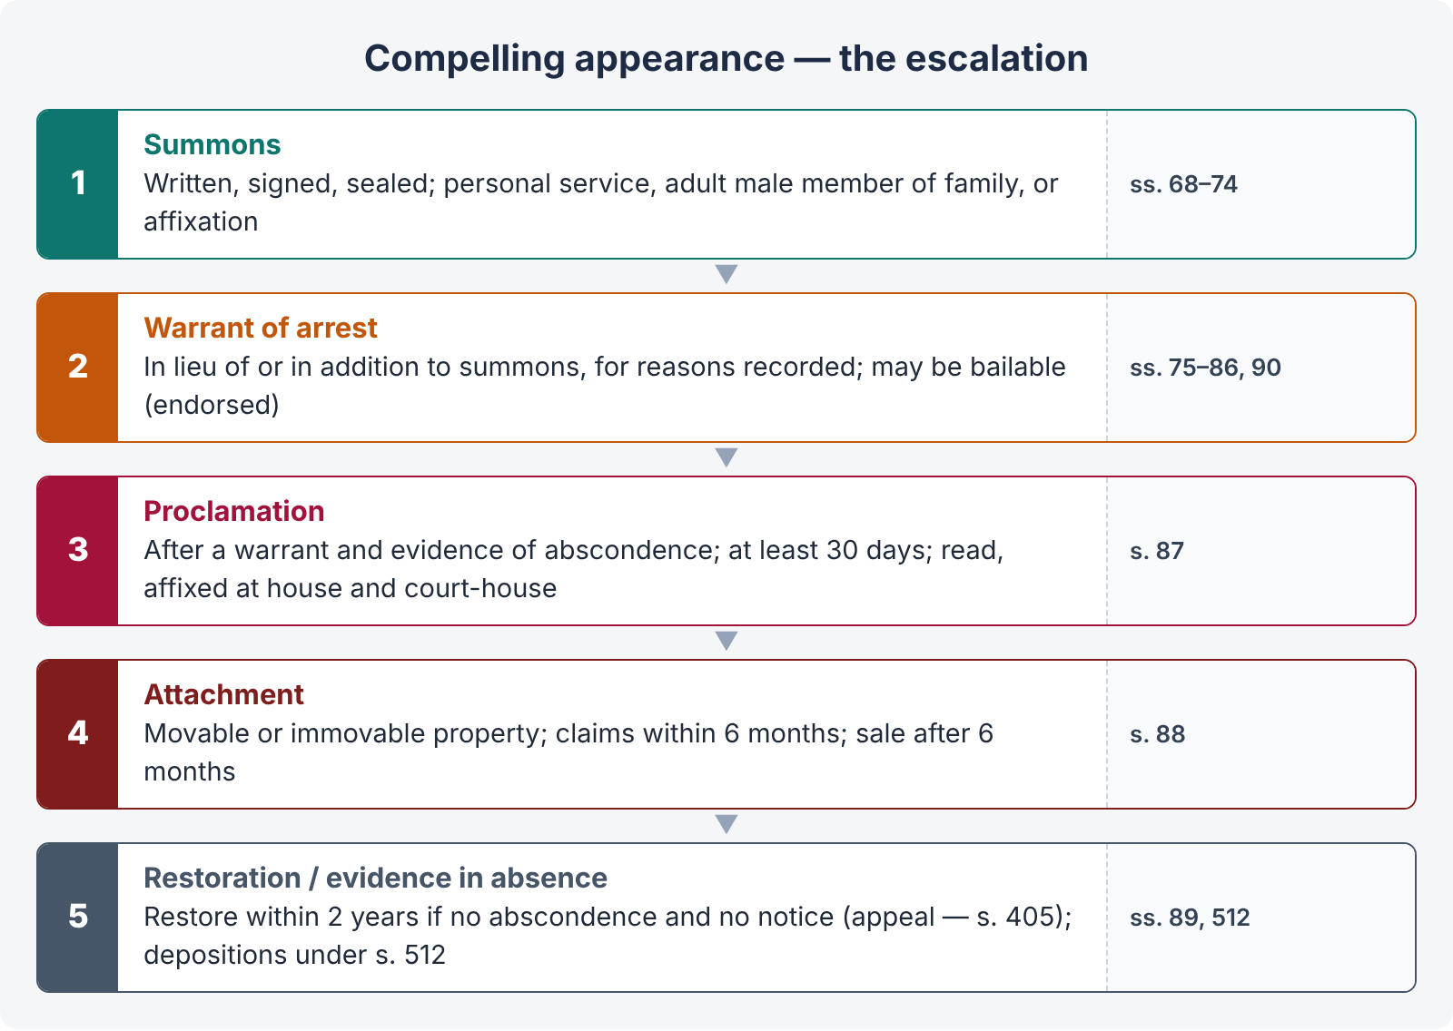
Figure 2 · Processes to compel appearance — the escalation

4.1 Summons — ss. 68 to 74
- Form (s. 68) — in writing, in duplicate, signed by the presiding officer and bearing the court's seal; served by a police officer or court officer.
- Personal service (s. 69) — by delivering or tendering one duplicate; the person served signs a receipt on the other.
- Service on an absent person (s. 70) — by leaving a duplicate with some adult male member of his family.
- Substituted service (s. 71) — if service cannot be effected under ss. 69–70, by affixing a duplicate on a conspicuous part of the house where he ordinarily resides.
- Service on a Government servant (s. 72) — through the head of his office; outside jurisdiction (s. 73); proof by affidavit (s. 74).

4.2 Warrant of arrest — ss. 75 to 86
- Form (s. 75) — in writing, signed, sealed; remains in force until cancelled or executed.
- Bailable warrant (s. 76) — the court may endorse the warrant directing that, if the person executes a bond with sureties, he shall be released (stating the number of sureties, the amount, and the time to attend).
- To whom directed (ss. 77–79) — ordinarily to a police officer; may be directed to any person (s. 78).
- Execution (ss. 80–82) — the officer shall notify the substance and, if required, show the warrant; bring the person before the court without delay (s. 81); may be executed anywhere in Pakistan (s. 82).
- Outside jurisdiction (ss. 83–86) — forwarded to a Magistrate or SP there; endorsement; the arrested person taken before the local Magistrate.
- Warrant in lieu of or in addition to summons — s. 90: after recording reasons, (a) if the court has reason to believe that the person has absconded or will not obey the summons, or (b) if he fails to appear after due service and offers no reasonable excuse.

4.3 Proclamation for a person absconding — s. 87 (LHC 2020, 2023; ASJ 2025)
- Condition — the court is satisfied after taking evidence that a person against whom it has issued a warrant has absconded or is concealing himself so that the warrant cannot be executed.
- Content — a written proclamation requiring him to appear at a specified place and time not less than thirty days from the date of publication.
- Publication — (a) publicly read in a conspicuous place of the town or village where he ordinarily resides; (b) affixed to a conspicuous part of his house or homestead or a conspicuous place of the town or village; and (c) a copy affixed to the court-house.
- Proof — a written statement by the court that it was duly published on a specified day is conclusive evidence (s. 87(3)).
Pre-conditions in short: a warrant first; evidence of abscondence (the process server's statement on oath); a full thirty days; all three modes of publication. Without these the proclamation, and the attachment, are illegal.

4.4 Attachment of property — s. 88
- The court issuing the proclamation may at any time order attachment of any property, movable or immovable, of the proclaimed person (within the district; outside it with the endorsement of the Sessions Judge of that district).
- Movable property (debts etc.) — by seizure, appointment of a receiver, a written prohibitory order against delivery, or any two.
- Immovable property — land paying revenue, through the Collector (District Officer (Revenue)); otherwise by taking possession, a receiver, a prohibitory order against payment of rent or delivery, or any two.
- Perishable property or livestock may be sold at once.
- Claims and objections by third persons (s. 88(6A)–(6D)) — within six months of attachment, inquired into and allowed or disallowed; a person whose claim is disallowed may sue in a civil court within one year to establish his right.
- If the proclaimed person does not appear within the time, the attached property is at the disposal of the Government; it may be sold after six months (s. 88(7)).

4.5 Restoration of attached property — s. 89 and the appeal under s. 405
If, within two years from the date of attachment, the person whose property is at the Government's disposal appears voluntarily or is apprehended, and proves to the satisfaction of the court that he did not abscond or conceal himself to avoid execution of the warrant, and that he had no such notice of the proclamation as would have enabled him to attend within the time, the property — or the net sale proceeds, or the proceeds and the residue — shall be delivered to him, after deducting the costs of attachment.
Remedy if restoration is refused — s. 405: "Any person whose application under section 89 for the delivery of property or the proceeds of the sale thereof has been rejected by any Court may appeal to the Court to which appeals ordinarily lie from the sentences of the former Court" (from a Magistrate — the Sessions Court; from a Sessions Court — the High Court).

4.6 Consequences of being a proclaimed offender (ASJ 2025; SHC 2022)
- Attachment and forfeiture of property (ss. 88–89).
- Any private person may arrest him (s. 59); police may arrest without warrant (s. 54).
- Evidence may be recorded in his absence (s. 512) and used later if the witness is dead or unavailable.
- Abscondence is a relevant circumstance that may corroborate other evidence against him — but it is not by itself proof of guilt (an innocent person may also flee fearing the police).
- Bail: a fugitive from law "loses some of his normal rights" — the superior courts hold that pre-arrest bail is an extraordinary relief, ordinarily not available to an absconder or proclaimed offender. The application is maintainable (the court has jurisdiction), but it is decided against him unless he shows that the proclamation was illegal, that he had no notice, or exceptional circumstances of mala fide (e.g., false implication shown on the record). For post-arrest bail, abscondence weighs heavily but does not automatically bar bail where the case is otherwise one of further inquiry.
- Limitation in civil matters is not affected; but his appeal or revision may not be heard while he remains a fugitive.

4.7 Bonds for appearance — ss. 91 to 93
The court may require a person present in court to execute a bond for his appearance (s. 91); arrest on breach (s. 92); provisions apply to all summonses and warrants (s. 93).

Chapter 5 · Search and seizure

5.1 Search warrants — when issued (LHC 2023)
- s. 96(1) — a court may issue a search warrant where (a) it has reason to believe that a person to whom a summons or order under s. 94 (to produce a document or thing) has been or might be addressed will not produce it; (b) the document or thing is not known to be in the possession of any person; or (c) a general search or inspection will serve the purposes of an inquiry, trial or other proceeding. (Documents in the custody of the Post or Telegraph authorities need a District Magistrate's or higher authority's warrant.)
- s. 98 — a Magistrate of the first class may issue a warrant to search a place suspected to contain stolen property, forged documents, false seals, counterfeit coin, obscene objects, or used for their deposit or sale, and to seize such things.
- s. 99A — search for and seizure of publications forfeited by Government.
- s. 100 — search for persons wrongfully confined — a Magistrate of the first class who has reason to believe that a person is confined in circumstances amounting to an offence may issue a warrant; the person found is taken before a Magistrate.

5.2 General rules of search
- s. 102 — the occupant of a closed place must allow free ingress; otherwise s. 48 (breaking doors).
- s. 103 — two or more respectable inhabitants of the locality must be called to witness the search; a list of things seized is prepared and signed by them; the occupant may attend and gets a copy. (The rule does not apply to searches under the CNSA 1997 — s. 25 CNSA excludes s. 103.)
- s. 165 — search by a police officer during investigation, after recording in writing the grounds of belief and the thing to be searched for; in person if practicable; copies of the record sent to the Magistrate; search of bank records only with the prior written permission of a Sessions Judge (for ss. 403, 406, 408, 409, 421–424, 465–477A PPC) or otherwise of the High Court.

Chapter 6 · Prevention of offences and public order (ss. 106 to 148)

6.1 Security proceedings
s. 106 | Security for keeping the peace on conviction for certain offences (breach of peace, intimidation) — up to three years
s. 107 | Security for keeping the peace in other cases — where a person is likely to commit a breach of the peace; show-cause; bond up to three years
s. 108 | Security for good behaviour from persons disseminating seditious matters
s. 109 | Security for good behaviour from vagrants and suspected persons
s. 110 | Security for good behaviour from habitual offenders — habitual robbers, house-breakers, thieves, forgers, receivers, harbourers, kidnappers, extortionists, and the desperate and dangerous
ss. 112–126 | Procedure — order setting forth the substance, inquiry, order to give security (s. 118), discharge (s. 119), imprisonment in default (s. 123); appeal to the Court of Session (s. 406); refusal of a surety appealable (s. 406A)

6.2 Nuisance, urgent orders and land disputes
- s. 133 — conditional order for removal of a public nuisance (obstruction of a public way, dangerous trade, building likely to fall, dangerous animal); the person may show cause; not questioned in a civil court.
- s. 144 — order absolute at once in urgent cases of nuisance or apprehended danger — directing a person or the public to abstain from an act; in force for not more than two consecutive days and seven days in a month unless Government extends it in cases of danger to life or riot.
- s. 145 — dispute concerning land or water likely to cause a breach of the peace: the Magistrate calls for written statements about actual possession, decides who was in possession on the date of the order (or was forcibly dispossessed within two months before it), and declares that party entitled to remain until evicted in due course of law; he may attach the property in an emergency. He does not decide title.
- s. 146 — attachment and receiver where possession cannot be decided.
- ss. 127–128 — dispersal of unlawful assemblies; firing only on the specific direction of a police officer not below ASP/DSP (s. 128 proviso).

Chapter 7 · Information to the police and investigation (ss. 154 to 176)
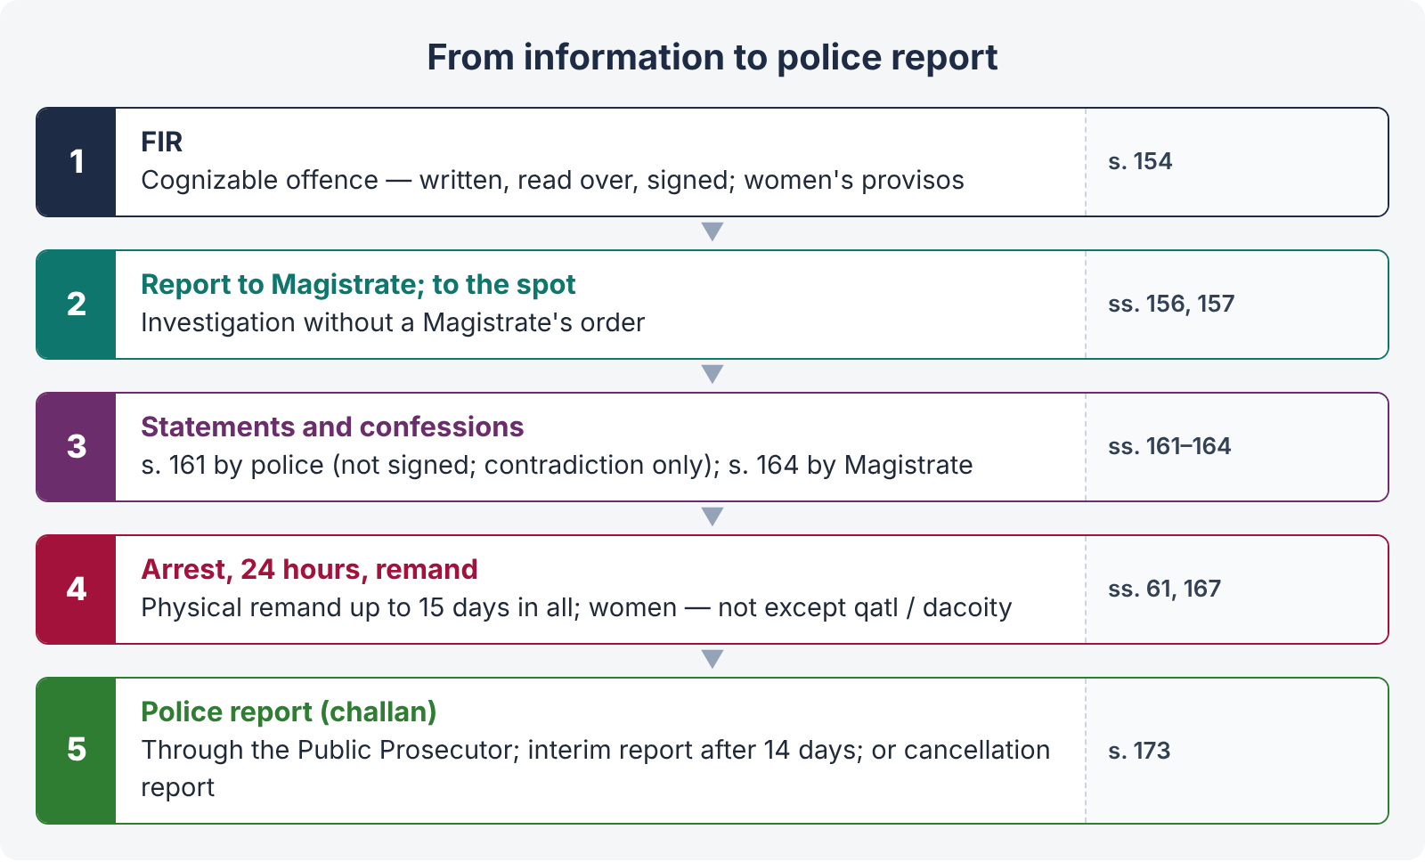
Figure 3 · From FIR to challan

7.1 First Information Report — s. 154
- Every information relating to a cognizable offence given to the officer in charge of a police station, if oral, shall be reduced to writing, read over to the informant, signed by him, and its substance entered in the prescribed book (the FIR register).
- Duty to register — the SHO must register an FIR if the information discloses a cognizable offence; he cannot first hold an inquiry into its truth (Muhammad Bashir v. SHO Okara Cantt, PLD 2007 SC 539). Remedy against refusal — s. 22A(6) petition, a private complaint, or Art. 199.
- Women victims (2016) — information from a woman about an offence under ss. 336B, 354, 354A, 376 or 509 PPC is recorded in the presence of a female police officer or a female family member or any person with her consent; if she is distressed, it is recorded at her residence or a place of her choice.
- Evidentiary value — the FIR is not substantive evidence; it may be used to corroborate its maker (Art. 153 QSO) or to contradict him (Arts. 140, 151 QSO), and as a dying declaration if the informant dies (Art. 46 QSO). Delay in lodging it, unexplained, casts doubt (room for consultation and deliberation).
CASE STUDY · Mst. Sughran Bibi v. The State (PLD 2018 SC 595)
A seven-member bench held that there can be only one FIR for one occurrence; a different version of the same incident by another person is not registered as a fresh FIR but recorded as a statement under s. 161 in the same case; the investigating officer must investigate all versions impartially; an accused is not to be arrested merely because he is named in the FIR unless the investigating officer finds sufficient material to justify arrest; and the police report under s. 173 must state the officer's own opinion on the facts.

7.2 Non-cognizable cases — s. 155
The SHO enters the substance in a book and refers the informant to the Magistrate; no investigation without a Magistrate's order; the investigating officer then has all powers except arrest without warrant.

7.3 Investigation — ss. 156 to 160
- s. 156 — the SHO may investigate a cognizable case without a Magistrate's order; a Magistrate empowered under s. 190 may order investigation (s. 156(3)).
- s. 156A — s. 295C PPC — investigation only by an officer not below Superintendent of Police.
- s. 156B — zina (not zina-bil-jabr) — investigation only by an officer not below SP, and no arrest without the court's permission.
- s. 157 — report to the Magistrate forthwith; proceed to the spot; no full investigation where the case is not serious or there is no sufficient ground (informant notified).
- s. 160 — the investigating officer may require the attendance of witnesses by written order.

7.4 Statements of witnesses — ss. 161, 162 (LHC 2023)
- s. 161 — the police may examine orally any person acquainted with the facts; he must answer truly except self-incriminating questions; the officer may reduce it into writing in a separate record for each person. A woman victim of ss. 336B, 354, 354A, 376, 509 — in the presence of a female police officer or family member.
- s. 161A (2016) — the victim of rape or sexual abuse must be told of the right to legal representation; free legal aid from Bar Council lists.
- s. 162 — a statement to the police shall not be signed, and cannot be used for any purpose at the trial, except (i) by the accused (and, with the court's permission, the prosecution) to contradict the witness under Art. 140 QSO (s. 145 Evidence Act), and in re-examination to explain; (ii) a dying declaration (Art. 46 QSO); and (iii) a discovery statement (Art. 40 QSO).
Point | Statement under s. 161 | Statement under s. 164
Recorded by | Police officer | Magistrate
Oath | No oath; not signed | Witness statement on oath may be recorded; a confession — not on oath
Evidentiary use | Only to contradict (s. 162) | A confession is substantive evidence; a witness statement corroborates or contradicts
Accused's presence | No | May be in the accused's presence with a right to cross-examine (s. 164(1A))

7.5 Confessions — s. 164 (LHC 2023)
- Who — any Magistrate of the first class, or a second-class Magistrate specially empowered, not being a police officer, during investigation or afterwards before the inquiry or trial begins.
- Warning — before recording, the Magistrate shall explain that the person is not bound to confess and that the confession may be used as evidence against him.
- Satisfaction — he shall not record it unless, upon questioning, he has reason to believe it is voluntary (the High Court Rules require time for reflection, removal of police from the court-room, assurance that the accused will not be sent back to police custody, and questions about any ill-treatment).
- Recording — in the manner of s. 364 (the accused's own words, read over, signed by him and the Magistrate), with the certificate at the foot: "I have explained to (name) that he is not bound to make a confession … I believe that this confession was voluntarily made …".
- Forwarding — to the Magistrate who will try or inquire into the case.
- Retraction — a retracted confession may still found a conviction if found voluntary and true, but the courts look for corroboration in material particulars. A confession to the police is inadmissible (Art. 38 QSO); in police custody, inadmissible unless before a Magistrate (Art. 39).

7.6 Medical examination and DNA — ss. 164A, 164B (2016)
The victim of rape, unnatural offence or sexual abuse must be examined immediately by a registered medical practitioner — a female doctor for a female victim — with consent, escorted where possible by a female police officer or family member; the report records age, DNA material, injuries, mental condition; DNA samples are collected from the victim and the accused and sent to a forensic laboratory, with confidentiality.

7.7 Remand — s. 167 and s. 344 (LHC 2023)
- When — the accused is arrested and the investigation cannot be completed in 24 hours and there are grounds for believing the accusation well-founded: the SHO (or an investigating officer not below sub-inspector) forwards the accused with a copy of the diary entries to the nearest Magistrate.
- Physical (police) remand — the Magistrate may authorise detention in such custody as he thinks fit, for not more than fifteen days in the whole; no third-class or unempowered second-class Magistrate may authorise police custody; reasons must be recorded; a copy goes to the Sessions Judge.
- Women (s. 167(5)–(7)) — a female accused shall not be remanded to police custody except in cases of qatl or dacoity, for reasons recorded; she is interrogated in prison in the presence of a jail officer and a female police officer; if she must be taken out, only with the Magistrate's permission, in the company of a female police officer, and never between sunset and sunrise.
- Judicial remand (s. 344) — after the police custody ends, or during inquiry or trial, the court may remand the accused to jail (judicial lock-up) by warrant, for not more than fifteen days at a time, when it postpones or adjourns. Explanation: if sufficient evidence has been obtained to raise a suspicion and further evidence may be obtained by a remand, that is reasonable cause.
Point | Physical remand (s. 167) | Judicial remand (s. 344)
Custody | Police | Jail (judicial custody)
Purpose | Interrogation, recovery, investigation | Keeping the accused during investigation, inquiry or trial
Limit | 15 days in the whole | 15 days at a time, renewable
By whom | Magistrate (first class or empowered) | Any court inquiring or trying
Women | Not, except qatl / dacoity | Ordinary rule

7.8 Release and report — ss. 169 to 173
- s. 169 — release on bond where evidence is deficient; s. 170 — forward the accused to the Magistrate where evidence is sufficient.
- s. 172 — the case diary, recorded day by day; the court may use it to aid an inquiry or trial but not as evidence; the accused cannot see it.
- s. 173 — police report (challan): completed without unnecessary delay, forwarded through the Public Prosecutor to the Magistrate; the informant is told of the action taken; if not completed within 14 days of the FIR, an interim report within three days after that, and the court shall commence the trial on it unless it decides otherwise for reasons; copy to the accused before trial; witnesses (other than public servants) produced and bound for appearance.
- Cancellation — where the police find the case false or without evidence, they submit a cancellation report; the Magistrate may agree (case cancelled), disagree and take cognizance (s. 190(1)(b)), or direct further investigation. The complainant may still file a private complaint.

7.9 Inquest, burns, death in custody — ss. 174 to 176 (LHC 2023)
- s. 174 — on information of suicide, killing by another, by an animal or machinery or accident, or death in suspicious circumstances, the SHO informs the nearest Magistrate empowered to hold inquests, goes to the spot, and in the presence of two or more respectable inhabitants prepares an inquest report describing wounds and the apparent cause of death; the body may be sent for post-mortem. First-class Magistrates may hold inquests.
- s. 174A — person grievously injured by burns (fire, kerosene, acid, chemical): the duty Medical Officer or SHO informs the Magistrate; the Medical Officer records the statement of the injured at once, and the Magistrate also records it if possible.
- Death in police custody — s. 176(1): the nearest Magistrate empowered to hold inquests shall hold an inquiry into the cause of death (it is mandatory), with all the powers he has in an inquiry into an offence, and may cause the body to be disinterred (s. 176(2)). The officers are liable under PPC (qatl, s. 337K torture) and the Torture and Custodial Death (Prevention and Punishment) Act 2022.

7.10 Remedies of a complainant when the police are protecting the accused (ASJ 2025)
- Petition to the ex-officio Justice of the Peace (s. 22A(6)) — for registration of the FIR, transfer of investigation, or directions against neglect, failure or excess.
- Change of investigation by the senior police hierarchy under the Police Order 2002 (the district police officer or higher, through a board, where the complaint is about the investigation's fairness).
- Private complaint under s. 200 on the same facts — the complainant leads his own evidence; where a complaint and a police case on the same occurrence are pending, the complaint case is tried first or both together (the settled practice).
- Magistrate's powers — on the s. 173 report, the Magistrate is not bound by the police opinion; he may take cognizance of the offence against the accused excluded by the police (s. 190(1)(b)), order further investigation, or summon witnesses.
- Trial court's powers — summon any person as a witness or produce omitted evidence (s. 540); add an accused where evidence appears (ss. 351, 190).
- High Court — Art. 199 (mandamus to register the FIR or transfer investigation in exceptional cases) and s. 561A to prevent abuse of process.
- Action against the police officer — departmental proceedings and the offences of wrongful confinement, false record (PPC ss. 218–219), and penalties under the Police Order 2002.

Chapter 8 · Cognizance and complaints (ss. 190 to 205)

8.1 Cognizance by Magistrates — s. 190
All Magistrates of the first class (and others specially empowered) may take cognizance of an offence (a) upon receiving a complaint of facts; (b) upon a police report in writing; (c) upon information from any other person, or upon their own knowledge or suspicion. A Magistrate who takes cognizance of an offence triable exclusively by a Court of Session shall, without recording evidence, send the case to the Court of Session (s. 190(2)). "Taking cognizance" is the application of judicial mind to the facts for the purpose of proceeding — not merely receiving papers.

8.2 Bars to cognizance — ss. 195 to 199
s. 195(1)(a) | Contempt of lawful authority of public servants (PPC ss. 172–188) — only on the written complaint of the public servant concerned or his superior
s. 195(1)(b) | Offences against public justice (false evidence ss. 193–196, 199, 200, 205–211, 228) committed in or in relation to a court proceeding — only on the written complaint of that court or its superior (procedure — s. 476)
s. 195(1)(c) | Forgery (s. 463) or using forged documents (ss. 471, 475, 476) by a party in respect of a document produced in court — only on the court's complaint
s. 196 | Offences against the State (Chapter VI), ss. 153A, 295A, 505 etc. — only on complaint by order of the Federal or Provincial Government
s. 197 | Judges, Magistrates and public servants removable only by Government — for acts in the discharge of official duty — previous sanction of the President or Governor
s. 198 | Breach of contract, defamation (Chapter XXI) and offences against marriage (ss. 493–496) — only on complaint by the person aggrieved (with leave, by another for a woman who does not appear in public, a minor, an idiot, or a sick person)
s. 199 | (Former) adultery and enticing a married woman — on complaint by the husband

8.3 Complaints to Magistrates — ss. 200 to 205
- s. 200 — the Magistrate taking cognizance on a complaint shall at once examine the complainant on oath; the substance is reduced to writing and signed. Exceptions — a written complaint by a court or a public servant in official duty; a case being transferred.
- s. 202 — postponement of process: for reasons recorded, the court may inquire itself or direct an inquiry or investigation by a Justice of the Peace, a police officer or any other person, to ascertain the truth of the complaint; a Court of Session may direct an inquiry by a subordinate Magistrate.
- s. 203 — dismissal of the complaint if, after considering the complainant's statement and the inquiry result, there is no sufficient ground for proceeding (brief reasons recorded). Dismissal is not acquittal — a fresh complaint lies on new material.
- s. 203A — zina complaint: only on a complaint in court; the court examines the complainant and at least four Muslim adult male eye-witnesses (subject to tazkiyah-al-shuhood) of the act of penetration; summons only if sufficient ground (Topic 4).
- s. 203C — fornication (s. 496B PPC): only on a complaint in court; the complainant and at least two eye-witnesses are examined on oath; no security except a personal bond; no fornication complaint against a person accused of zina or against a rape complainant or victim.
- s. 204 — issue of process: summons or warrant according to column 4 of Schedule II; process fees.
- s. 205 — the Magistrate may dispense with the personal attendance of the accused and permit appearance by a pleader.

Chapter 9 · The charge (ss. 221 to 240) — KPHC 2026; ASJ 2025; SHC 2022

9.1 Purpose
The charge tells the accused precisely what he must meet, so that he can prepare his defence. It is the foundation of the trial; in Sessions trials it is framed after the documents are supplied (s. 265D), and in Magistrate trials after the evidence or documents show a prima facie case (s. 242).

9.2 Contents of a charge — ss. 221 to 224
- The offence (s. 221(1)); its specific name if the law gives one (s. 221(2)); if not, enough of the definition to give notice (s. 221(3)).
- The law and section (s. 221(4)).
- The charge is equivalent to a statement that every legal condition required to constitute the offence was fulfilled (s. 221(5)).
- Language — English or the language of the court (s. 221(6)).
- Previous conviction — the fact, date and place, where enhanced punishment is sought (s. 221(7)).
- Particulars of time, place and person or thing (s. 222(1)); for criminal breach of trust or misappropriation of money, the gross sum and the dates between which it was committed — one offence, provided the period does not exceed one year (s. 222(2)).
- Manner of committing the offence where ss. 221–222 do not give sufficient notice (s. 223) — needed for cheating, false evidence, obstruction of a public servant; not for theft or murder.
- Words used in the charge are taken in the sense of the law (s. 224).

9.3 Effect of errors, alteration — ss. 225 to 232
- s. 225 — no error or omission in the charge is material unless the accused was in fact misled and it has occasioned a failure of justice (illus.: wrong name of the deceased and wrong date — immaterial where the accused knew which murder was meant).
- s. 227 — any court may alter or add to a charge at any time before judgment is pronounced; the alteration is read and explained to the accused.
- ss. 228–229 — the trial proceeds at once if there is no prejudice; otherwise a new trial or adjournment.
- s. 230 — stay where the altered charge needs previous sanction.
- s. 231 — witnesses may be recalled after alteration.
- s. 232 — an appellate or revisional court finding that the accused was misled by the absence of or an error in the charge shall order a new trial; if no valid charge could be framed on the facts, it shall quash the conviction.

9.4 Joinder of charges — ss. 233 to 240
The basic rule (s. 233): for every distinct offence there shall be a separate charge, and every charge shall be tried separately — except in the cases of ss. 234, 235, 236 and 239.
s. 234 | Three offences of the same kind within twelve months — whether against the same person or not — may be charged and tried together. "Same kind" — punishable with the same amount under the same section; theft (s. 379) and theft in a dwelling (s. 380) are the same kind; an offence and its attempt are the same kind.
s. 235(1) | Offences committed in one series of acts so connected as to form the same transaction — e.g., rescuing a prisoner and causing hurt to the constable (ss. 225, 333)
s. 235(2) | An act falling within two definitions — e.g., rioting and grievous hurt
s. 235(3) | Acts which separately constitute offences and combined a different offence — e.g., house-breaking with intent to commit adultery and the adultery
s. 236 | Where it is doubtful which of several offences the facts will constitute — charge with all or in the alternative (theft, or receiving, or CBT, or cheating; contradictory statements on oath — false evidence)
s. 237 | Conviction of an offence not charged where it could have been charged under s. 236
s. 238 | Conviction of a minor (included) offence — where the offence charged consists of several particulars and some only are proved (e.g., charged with robbery, convicted of theft)
s. 239 | Joint trial of several persons — (a) the same offence in the same transaction; (b) an offence and its abetment or attempt; (c) offences of the same kind committed jointly within 12 months; (d) different offences in the same transaction; (e) theft, extortion or misappropriation and receiving the property; (f) receiving property from the same distribution; (g) offences under ss. 231–233 and 241–243 relating to counterfeit coin
s. 240 | On conviction on one of several charges, the remaining charges may be withdrawn with the court's consent — operates as acquittal on them

9.5 Misjoinder and non-joinder — impact on the trial
- Misjoinder — joining charges or accused not permitted by ss. 234–239 (e.g., four thefts in one trial; unconnected offences of different persons). Earlier view (Subrahmania Ayyar v. King-Emperor, 1901, PC) — an illegality vitiating the trial. Present view in Pakistan — a misjoinder is an irregularity curable under s. 537 unless it has occasioned a failure of justice (prejudice to the defence, confusion of evidence). The appellate court may order a retrial.
- Non-joinder — failure to join charges or accused who could have been tried together — no illegality, since separate trial is the rule (s. 233); at most inconvenience or inconsistent findings.
- Absence of a charge where one was required — the conviction is set aside and a new trial ordered if the accused was misled (s. 232); or quashed if no valid charge could be framed.

9.6 How to frame a charge (model)
ILLUSTRATION · Charge — a robbery on a highway (ASJ 2025 type)
I, (name), Additional Sessions Judge, Islamabad (West), do hereby charge you, (1) Salman son of …, and (2) Noman son of …, as follows:
That on 12.03.2022 at about 3:45 p.m., near Liaquat Flyover, within the area of police station …, you both, armed with 9 mm pistols and riding a motorcycle, in furtherance of your common intention, intercepted the car No. ABC-123 driven by Adnan with Farooq, put them in fear of instant death at gun-point and robbed them of (cash Rs. …, mobile phones …), and thereby committed an offence punishable under section 392 read with section 34 of the Pakistan Penal Code, which is within the cognizance of this Court.
Secondly, that at the same time and place, while committing the said robbery, you used deadly weapons … punishable under section 397 PPC. Thirdly (if a shot was fired): that you, with the intention of causing death, fired at Adnan, which hit him on the left arm, causing ghayr-jaifah mudihah, and thereby committed offences punishable under sections 324 and 337F(iv) read with section 34 PPC.
And I hereby direct that you be tried by this Court on the said charge.
(Signed and dated) — Read over and explained to the accused, who pleaded not guilty and claimed trial.

Chapter 10 · Trials
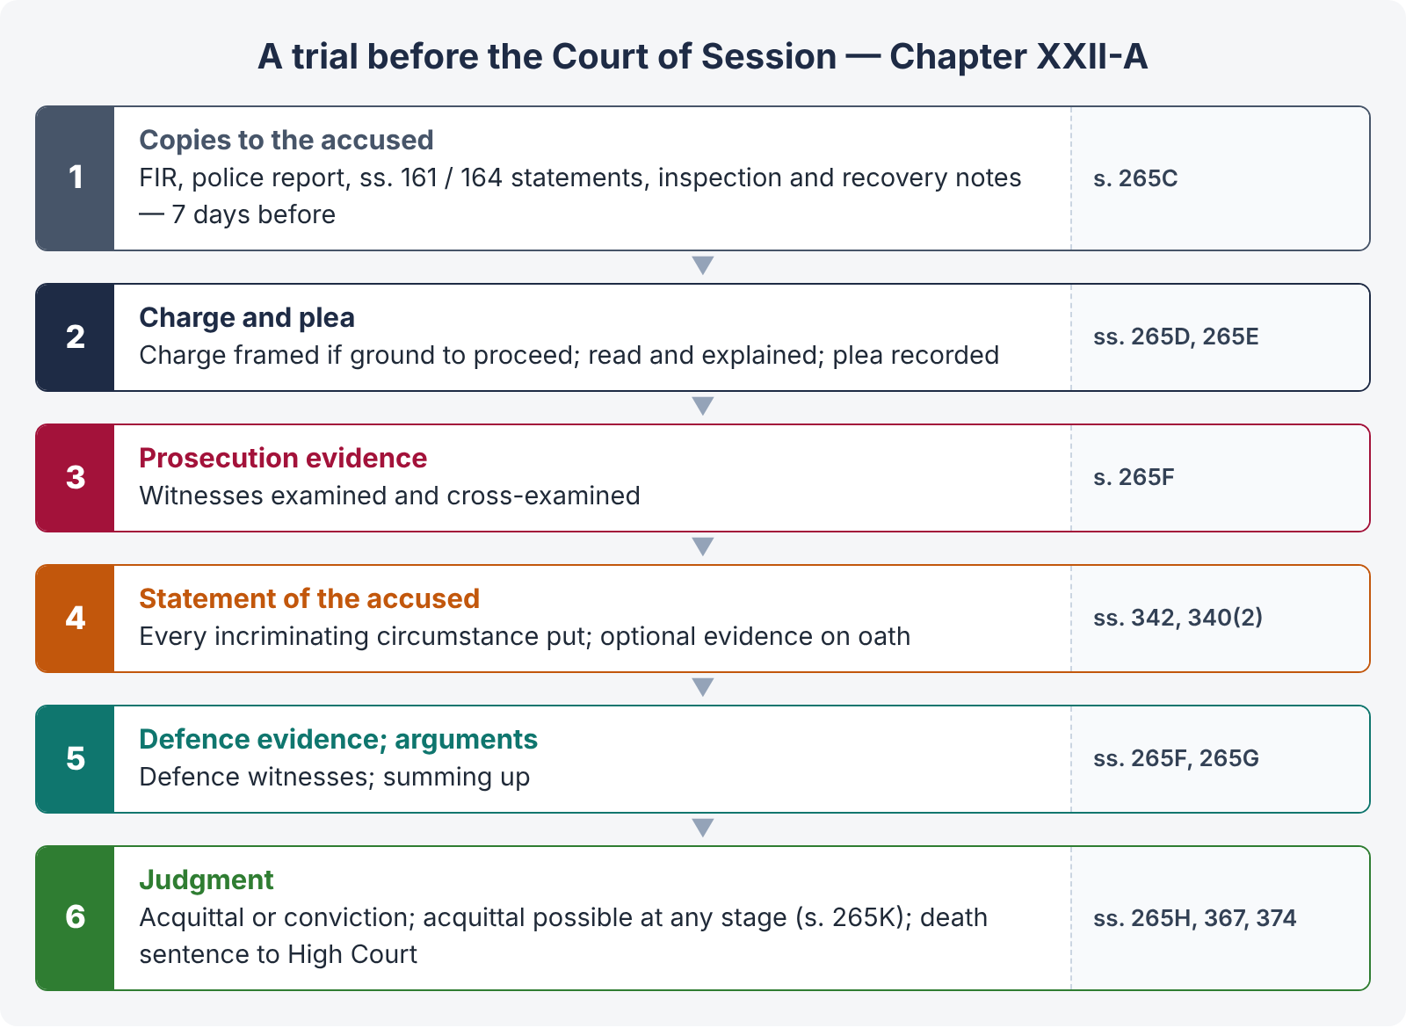
Figure 4 · The course of a Sessions trial

10.1 Summary trials — ss. 260 to 265
- Who — a Magistrate of the first class specially empowered, or a Bench so empowered (s. 260).
- What — offences not punishable with death, transportation or imprisonment exceeding six months; weights and measures (ss. 264–266 PPC); hurt; theft, receiving or misappropriation where the value does not exceed a stated amount; house-trespass to commit such theft; insult with intent to provoke breach of peace; criminal intimidation; abetment and attempt of these.
- Procedure — that of summons trials (Chapter XX); no sentence exceeding three months (s. 262(2)).
- Record — where no appeal lies, no need to record evidence or frame a formal charge — only the particulars of s. 263 (serial number, dates, complainant, accused, offence, plea, finding, sentence); where an appeal lies, the substance of the evidence and a judgment (s. 264).

10.2 Trials before Magistrates — ss. 241 to 250
- s. 241A — copies of s. 161 and s. 164 statements and the inspection note supplied free to the accused at least seven days before trial (police cases, other than summary or six-month cases); in complaint cases, the complainant supplies copies.
- s. 242 — the charge is framed and read over; the accused is asked whether he pleads guilty.
- s. 243 — on a plea of guilty, the Magistrate may convict.
- s. 244 — otherwise, prosecution evidence, then the defence.
- s. 245 — acquittal or conviction and sentence (s. 245A — proof of previous conviction after conviction).
- s. 247 — non-appearance of the complainant in a complaint case — the Magistrate shall acquit unless he adjourns — not where the offence is cognizable or non-compoundable.
- s. 248 — withdrawal of the complaint with the Magistrate's permission — acquittal.
- s. 249 — stopping proceedings in cases not on complaint — release with the effect of discharge.
- s. 249A — acquittal at any stage if, after hearing the prosecutor and the accused and for reasons recorded, the charge is groundless or there is no probability of conviction.
- s. 250 — compensation for false, frivolous or vexatious accusation, payable by the complainant or informant.

Instances in which a Magistrate records an acquittal (SHC 2022)
s. 245(1) | On the evidence, the accused is not guilty
s. 247 | Complainant absent on the date of hearing (non-cognizable, compoundable offences)
s. 248 | Withdrawal of the complaint with permission
s. 249A | Groundless charge or no probability of conviction, at any stage
s. 345(6) | Composition of an offence has the effect of an acquittal
s. 494(b) | Withdrawal from prosecution by the Public Prosecutor after the charge
s. 240 | Withdrawal of remaining charges after conviction on one

10.3 Trials before High Courts and Courts of Session — ss. 265A to 265N
- s. 265A — prosecution conducted by the Public Prosecutor.
- s. 265C — copies to the accused at least seven days before trial: (a) the FIR, (b) the police report, (c) statements under ss. 161 and 164, (d) the inspection note and recovery notes; in complaint cases, the complaint, documents and statements under ss. 200, 202.
- s. 265D — if there is ground for proceeding, the court frames a charge in writing.
- s. 265E — the charge is read and explained; the accused is asked to plead; a plea of guilty is recorded and the court may convict (it is not bound to, especially in capital cases).
- s. 265F — prosecution evidence; refusal to summon a witness called for vexation (reasons recorded); the accused's defence evidence; written statement filed.
- s. 265G — summing up — the prosecutor and then the defence address the court.
- s. 265H — acquittal or conviction; s. 265I — previous conviction proved after conviction.
- s. 265K — the court may acquit at any stage if there is no probability of conviction, after hearing both sides and recording reasons.
- s. 265L — the Public Prosecutor may withdraw a case under s. 494.

10.4 Examination of the accused — s. 342 (LHC 2023)
- Purpose — to enable the accused to explain any circumstance appearing in the evidence against him (audi alteram partem).
- When — the court may question him at any stage without warning, and shall question him generally on the case after the prosecution witnesses have been examined and before he is called on for his defence.
- Every incriminating piece of evidence must be put to him; a circumstance not put cannot be used against him.
- No oath (s. 342(4)), no punishment for refusing or for false answers, but the court may draw inferences (s. 342(2)); the answers may be used for or against him in the trial.
- Statement on oath — s. 340(2): the accused may (if he does not plead guilty) give evidence on oath in disproof of the charge; he is then a witness, subject to cross-examination, but protected from questions about other offences or bad character except in three situations.

10.5 Recording evidence in the absence of the accused — s. 512 (LHC 2023)
- Absconding accused (s. 512(1)) — if it is proved that the accused has absconded and there is no immediate prospect of arresting him, the court competent to try (or send for trial) may examine the prosecution witnesses in his absence and record their depositions. On his arrest, the depositions may be given in evidence against him only if the deponent is dead, incapable of giving evidence, or his attendance cannot be procured without unreasonable delay, expense or inconvenience.
- Offender unknown (s. 512(2)) — where an offence punishable with death or life imprisonment has been committed by persons unknown, the High Court may direct a first-class Magistrate to hold an inquiry and examine witnesses; the depositions may be used against a person later accused if the deponent is dead, incapable or beyond Pakistan.
- s. 540A — where two or more accused are before the court, one incapable of remaining may be excused if represented by a pleader.

10.6 Death of an accused during trial (LHC 2023)
- The Code contains no express provision for a pending trial; but criminal liability is personal — on the accused's death, the proceedings abate as against him and the case is consigned (filed) to the record, with no finding of guilt or innocence.
- The trial continues against co-accused.
- Appeals — every appeal (other than against a sentence of fine) abates on the death of the appellant; an appeal against acquittal abates on the death of the accused (s. 431). An appeal against fine survives because the fine is recoverable from his estate (PPC s. 70). Diyat, arsh and daman are likewise recoverable from the estate (PPC ss. 331(3), 337X(3)).
- Property produced in the case is dealt with under s. 517.

10.7 Other general provisions
- s. 337 — tender of pardon to an accomplice (offences triable by the Sessions Court, or punishable with up to 10 years, and certain others) on condition of full and true disclosure; s. 339 — prosecution if he breaks the condition.
- s. 344A — offences under ss. 354A, 376, 377 and 377B PPC must be decided within three months of cognizance, failing which the matter is brought to the notice of the Chief Justice of the High Court.
- s. 345 — compounding: (1) offences in the first table compoundable without permission by the persons named (e.g., hurt-type minor offences, defamation, criminal trespass); (2) offences in the second table compoundable with the permission of the court — including all Qisas and Diyat offences (by heirs or victim, subject to s. 311 PPC); abetment and attempt (s. 345(3)); a guardian for a minor or lunatic (s. 345(4)); while an appeal is pending, only with leave of the appellate court (s. 345(5)); composition = acquittal (s. 345(6)); only as provided (s. 345(7)).
- s. 349 — a Magistrate who finds the accused deserving of greater punishment than he can award submits the case to a Chief Judicial / s. 30 Magistrate.
- s. 353 — evidence shall be taken in the presence of the accused (or his pleader where attendance is dispensed with).
- s. 364 — record of the examination of the accused in full, in the language used, read over, and signed.
- s. 403 — double jeopardy: a person once convicted or acquitted by a competent court shall not be tried again for the same offence, nor on the same facts for any other offence for which a different charge might have been made (s. 236) or a conviction recorded (s. 237) — also Art. 13 of the Constitution.
- s. 540 — the court may summon any person as a witness at any stage, and shall if his evidence is essential to the just decision of the case.
- s. 544A — compensation to the heirs of a person killed, or to a person hurt, or for mental anguish, or for property loss — ordered on conviction unless reasons are recorded; recoverable as arrears of land revenue; default imprisonment up to six months.

10.8 Identification parade (SHC 2022)
A test identification parade is an aid to investigation, conducted by a Magistrate (usually in jail) where the witness did not know the accused before the occurrence. Safeguards: the accused is kept muffled after arrest; dummies of similar appearance (at least nine for one accused); the witnesses are kept apart; the Magistrate records objections, and the role each witness ascribes to the accused; held promptly. It is not substantive evidence — the substantive evidence is the identification in court; the parade corroborates it (Art. 22 QSO — facts establishing identity are relevant). A parade with defects, or identification without specifying the role, has little value.

10.9 Judgment — ss. 366 to 373
- s. 366 — pronounced in open court, in the court's language or one the accused understands; the accused attends (except where only fined or acquitted and attendance was dispensed with).
- s. 367 — written by the presiding officer, containing the points for determination, the decision and the reasons; dated and signed in open court; it must specify the offence, the section and the punishment; in a doubtful case, judgment in the alternative; an acquittal directs that the accused be set at liberty; where the offence is punishable with death and a lesser sentence is passed, the reasons why death was not awarded.
- ss. 374–376 — a death sentence is submitted to the High Court for confirmation; the High Court may confirm, pass another sentence, convict of another offence, order a new trial, or acquit.
- s. 382 — a woman sentenced to death found pregnant — the High Court shall postpone execution and may commute the sentence to imprisonment for life.
- s. 382A — sentences under one year (or s. 476) not executed till the appeal period expires if bail is furnished.
- s. 382B — the court shall consider the period of pre-sentence custody when awarding imprisonment.
- s. 382C — the court may take into account scandalous or false and frivolous pleas in sentencing.

Chapter 11 · Bail (ss. 496 to 498A) — KPHC 2026; ASJ 2025

11.1 Meaning and philosophy
Bail is the release of an accused from custody on security (a bond with or without sureties) that he will appear when required. It reconciles the presumption of innocence and the right to liberty (Art. 9) with the State's interest in securing the accused's attendance and protecting the investigation. Bail is not acquittal; the grant of bail is a tentative assessment, and the trial court is not bound by it.
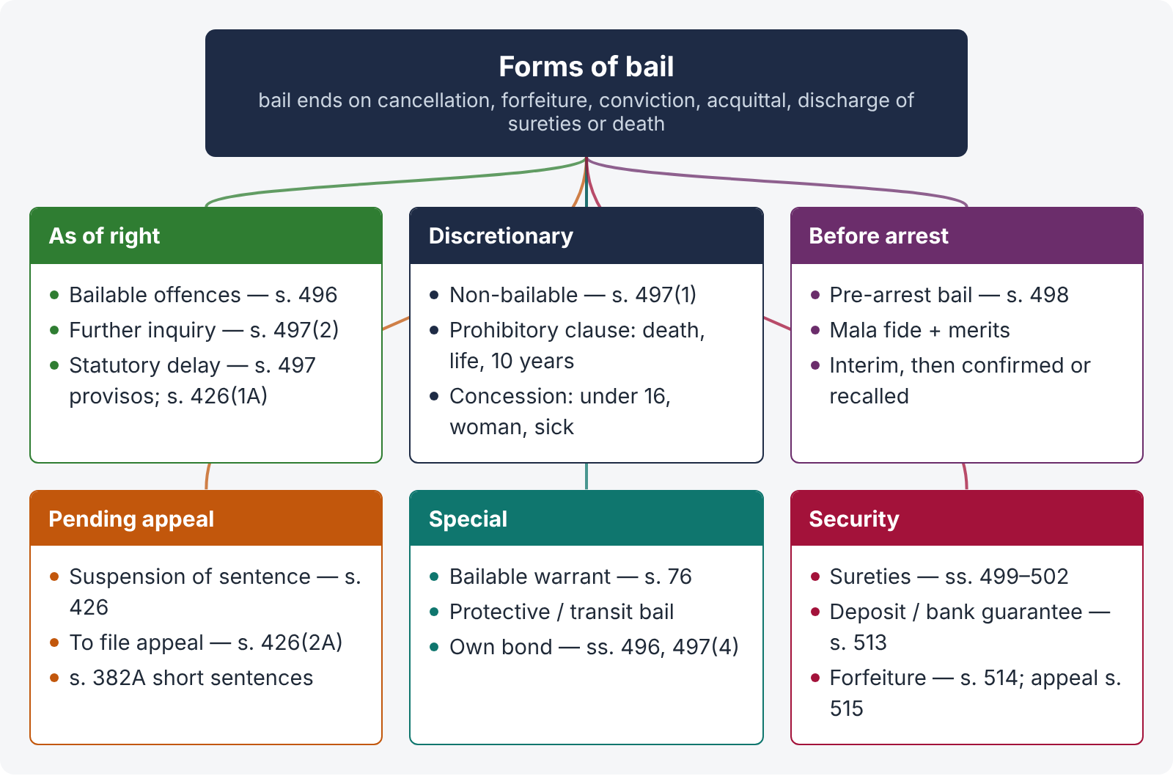
Figure 5 · Forms of bail

11.2 Bailable offences — s. 496
A person accused of a bailable offence, arrested without warrant or appearing before a court, shall be released on bail if prepared to give it — bail is his right; the officer or court may instead release him on a personal bond without sureties.

11.3 Non-bailable offences — s. 497
- Discretion — such a person "may be released on bail", but shall not be released "if there appear reasonable grounds for believing that he has been guilty of an offence punishable with death or imprisonment for life or imprisonment for ten years" — the prohibitory clause.
- First proviso — concession — the court may release on bail a person under sixteen, any woman, or any sick or infirm person, even in a prohibitory-clause offence.
- Second proviso — statutory bail for delay — the court shall release on bail (unless the delay was caused by the accused or his agents): (a) an accused of an offence not punishable with death detained continuously for more than one year (a woman — six months) whose trial has not concluded; (b) an accused of an offence punishable with death detained for more than two years (a woman — one year).
- Third proviso — exclusions from statutory bail: a previously convicted offender for an offence punishable with death or life, a hardened, desperate or dangerous criminal, or a person accused of terrorism punishable with death or life.
- s. 497(2) — further inquiry: if at any stage there are not reasonable grounds to believe the accused committed a non-bailable offence, but there are sufficient grounds for further inquiry into his guilt, he shall be released on bail — bail then becomes a right.
- s. 497(3) — reasons must be recorded when releasing.
- s. 497(4) — after the trial concludes and before judgment, if there are reasonable grounds to believe the accused is not guilty, he shall be released on his own bond.
- s. 497(5) — the High Court or Court of Session (and the releasing court for its own order) may cancel bail and commit the accused to custody.

11.4 "Reasonable grounds" and "further inquiry" (ASJ 2025)
- Reasonable grounds — more than mere allegations or suspicion; the court looks at the material collected (FIR, statements, medical evidence, recoveries, the accused's specific role) tentatively, without a deep appraisal of evidence, to see whether there is prima facie material connecting him with an offence in the prohibitory clause.
- Further inquiry — where the material leaves reasonable doubt about guilt: e.g., two versions of the occurrence; a general or ineffective role (e.g., lalkara, no injury attributed); the applicability of a lesser section (whether s. 302 or s. 316 or s. 324 is attracted); delay in the FIR unexplained; contradictions with the medical evidence; co-accused with a similar role already bailed (rule of consistency); a case resting on documents already in police possession; civil nature of the dispute (cheques, contracts); the benefit of doubt principle applies even at the bail stage.
- Offences outside the prohibitory clause — "grant of bail is a rule and refusal an exception" (Tariq Bashir v. The State, PLD 1995 SC 34); refusal only for extraordinary reasons — likelihood of absconding, tampering with prosecution evidence, repeating the offence, or being a previous convict.
- Rule of consistency (SHC 2022) — an accused whose role is identical to that of a co-accused already granted bail is ordinarily entitled to bail on the same footing; a distinguishable role defeats the rule.

11.5 Concurrent powers and pre-arrest bail — ss. 498, 498A
- s. 498 — the High Court or Court of Session may, in any case, whether there is an appeal or not, direct that any person be admitted to bail, or that the bail fixed by a police officer or Magistrate be reduced. Pre-arrest bail (bail before arrest, "anticipatory bail") is derived from this section.
- s. 498A — no bail to a person not in custody, not present in court, or against whom no case is registered; and bail is effective only for the case registered and specified in the order. So a pre-arrest bail petitioner must appear in person, and a "blanket" bail for future cases cannot be granted.

Principles of pre-arrest bail
- It is an extraordinary relief, meant to protect innocent persons against harassment and humiliation by arrest in a case launched with mala fide or ulterior motives (Murad Khan v. Fazal-e-Subhan, PLD 1983 SC 82; Meeran Bux v. The State, PLD 1989 SC 347).
- The petitioner must show (i) mala fide of the complainant or police, or that arrest would cause irreparable humiliation; and (ii) a prima facie case for bail on merits (Rana Muhammad Arshad v. Muhammad Rafique, PLD 2009 SC 427).
- Ordinarily the petitioner must first approach the Court of Session before the High Court (hierarchy).
- Pre-arrest bail is not a device to avoid recovery or interrogation where recovery is to be effected from the accused.
- Interim pre-arrest bail is granted until the final hearing; if the petition is dismissed, the accused is arrested in court; if confirmed, he remains on bail.
- Proclaimed offenders / absconders ordinarily cannot claim it (Chapter 4.6).
- Protective (transit) bail — a High Court may grant short protective bail to enable a person to appear before the court of competent jurisdiction in another province or territory.

11.6 Bail pending appeal — s. 426
The appellate court may suspend the sentence and release the appellant on bail for reasons recorded (s. 426(1)). Statutory release (s. 426(1A)) unless the appellant caused the delay: sentence up to 3 years — appeal not decided within six months; over 3 and up to 7 years — within one year; life or over 7 years — within two years; with the same exclusions as s. 497. A court convicting for a bailable offence may grant bail to enable an appeal (s. 426(2A)). Time on bail is excluded from the sentence (s. 426(3)).

11.7 Bonds and sureties — ss. 499 to 502
- s. 499 — a bond by the accused and, for bail, by one or more sufficient sureties, conditioned on attendance.
- s. 500 — release as soon as the bond is executed (release order to the jail).
- s. 501 — if the sureties prove insufficient, the court may issue a warrant and require sufficient sureties.
- s. 502 — a surety may apply to be discharged; the court issues a warrant, and on the accused's appearance discharges the bond and calls for other sureties.

11.8 Termination of bail (KPHC 2026)
Bail comes to an end:
- by cancellation — s. 497(5) (by the High Court, Sessions Court or the granting court) or under s. 498 — on grounds of misuse: tampering with evidence, threatening witnesses, absconding, committing a fresh offence, violating conditions, or where the order was perverse or passed without jurisdiction (the grounds for cancellation are narrower than for refusal);
- by discharge of the bond at the surety's request (s. 502), or the death or insolvency of a surety (s. 514A — fresh security);
- on forfeiture of the bond for non-appearance (s. 514);
- by a conviction and sentence of imprisonment (bail ends unless the sentence is suspended under s. 426);
- by an acquittal or discharge, or the cancellation of the case;
- by the expiry of interim bail or the dismissal of a pre-arrest bail petition;
- on the death of the accused.

11.9 Deposit, forfeiture and appeal — ss. 513 to 516 (LHC 2020)
- s. 513 — deposit instead of a bond: when any person is required to execute a bond, with or without sureties, the court or officer may — except in the case of a bond for good behaviour — permit him to deposit a sum of money or Government promissory notes or furnish a bank guarantee (Act XXXIII of 2022) in lieu of executing the bond.
- s. 514 — forfeiture: when it is proved to the satisfaction of the court (or a first-class Magistrate) that the bond has been forfeited, the court records the grounds, and calls upon the person bound to pay the penalty or show cause; if sufficient cause is not shown and the penalty is not paid, it may be recovered by attachment and sale of his movable property (and, in the ICT, immovable property — Act XXXVI of 2026) or his estate; if not recoverable — civil jail up to six months; the court may remit part of the penalty (in the ICT not more than half of the surety amount); a surety's estate is discharged if he dies before forfeiture.
- s. 514A — fresh security on the insolvency or death of a surety or on forfeiture; s. 514B — a minor may give a bond through sureties only.
- s. 515 — appeal and revision: all orders passed by any Magistrate under s. 514 are appealable to the Sessions Judge, or, if no appeal is preferred, may be revised by the Sessions Judge (and the High Court under ss. 435, 439).
- s. 516 — the High Court or Court of Session may direct a Magistrate to levy the amount due on a bond for appearance before it.

11.10 Bail in a s. 489F case — model order outline (SHC 2022)
ILLUSTRATION · Order (outline)
"The applicant seeks post-arrest bail in case FIR No. … under s. 489F PPC. The prosecution alleges that he issued a cheque for the price of goods which was dishonoured on presentation. Learned counsel for the applicant contends that the goods supplied were defective and that the applicant stopped payment for that reason. Heard. Record perused. 1. The offence carries a maximum of three years and does not fall within the prohibitory clause of s. 497(1) Cr.P.C.; in such cases grant of bail is the rule and refusal an exception (Tariq Bashir v. The State, PLD 1995 SC 34). 2. Whether the cheque was issued dishonestly and towards an obligation which subsisted after the goods were found defective is a question requiring further inquiry within s. 497(2). 3. The documentary evidence is in the possession of the prosecution and there is no likelihood of tampering; the applicant is not a previous convict and is no longer required for investigation. 4. Keeping him in jail would serve no useful purpose; the civil dispute is pending. Bail is granted subject to his furnishing a bail bond of Rs. … with one surety in the like amount to the satisfaction of the trial court. The observations are tentative and shall not prejudice the trial."

Chapter 12 · Appeals, revision and inherent powers

12.1 Appeals — the scheme
- No appeal except as provided (s. 404).
- From a Magistrate (s. 30 or otherwise) or an Assistant Sessions Judge — to the Court of Session; but from an Assistant Sessions Judge's sentence exceeding four years — to the High Court (s. 408).
- From a Sessions Judge or Additional Sessions Judge — to the High Court (s. 410).
- From the High Court's original criminal jurisdiction — to a Division Bench (s. 411A).
- Against acquittal — s. 417: (1) the Government may direct the Public Prosecutor to appeal to the High Court against any acquittal by a court other than the High Court; (2) in a complaint case, the complainant may appeal with the High Court's special leave; (2A) any person aggrieved by an acquittal by a court other than the High Court may appeal within thirty days.

12.2 Cases in which no appeal lies — ss. 412 to 415 (LHC 2020)
s. 412 | Plea of guilty — where the accused pleaded guilty and was convicted on that plea by a High Court, Court of Session or first-class Magistrate, there is no appeal except as to the extent or legality of the sentence
s. 413 | Petty cases — no appeal where (a) the High Court passes imprisonment not exceeding six months only or fine not exceeding Rs. 200 only; (b) a Court of Session passes imprisonment not exceeding one month only; (c) a Court of Session or first-class Magistrate passes a fine not exceeding Rs. 50 only. Explanation: imprisonment in default of fine alone is not appealable
s. 414 | Summary convictions — no appeal where a Magistrate empowered under s. 260 passes a sentence of fine not exceeding Rs. 2,000 only
s. 415 | Proviso to ss. 413 and 414 — an appeal lies against such a sentence where it is combined with any other punishment; but a sentence is not appealable merely because the convict is also ordered to give security to keep the peace; and imprisonment in default of fine is not a combination of punishments

12.3 Procedure in appeal — ss. 419 to 431
- Petition of appeal with a copy of the judgment (s. 419); summary dismissal only after hearing (s. 421).
- Powers (s. 423) — in an appeal from acquittal: reverse and order retrial or convict; from conviction: reverse and acquit or order retrial, alter the finding, reduce the sentence — but not enhance it (enhancement only in revision after notice); any amendment or incidental order.
- Abatement (s. 431) — Chapter 10.6.

12.4 Revision — ss. 435 to 439A
- s. 435 — the High Court or Sessions Judge may call for the record of any proceeding of an inferior criminal court to satisfy itself as to the correctness, legality or propriety of any finding, sentence or order and the regularity of proceedings, and may suspend the sentence or release the accused on bail meanwhile.
- s. 439 — High Court's powers: any power of an appellate court (ss. 423, 426–428) and enhancement of sentence after hearing the accused (s. 439(2), (6)); but it cannot convert an acquittal into a conviction (s. 439(4)(a)); no revision at the instance of a party who could have appealed but did not (s. 439(5)).
- s. 439A — Sessions Judge's powers — the same powers in respect of Magistrates' proceedings; an Additional Sessions Judge exercises them in transferred cases; no revision to the High Court against a Sessions Judge's s. 439A order (s. 439(4)(b)) — the remedy is s. 561A or Art. 199.

12.5 Inherent powers — s. 561A
"Nothing in this Code shall be deemed to limit or affect the inherent power of the High Court to make such orders as may be necessary to give effect to any order under this Code, or to prevent abuse of the process of any Court, or otherwise to secure the ends of justice." It is used to quash proceedings that are groundless or an abuse, but it is not an alternative to appeal or revision and is exercised sparingly; the Sessions Court has no inherent powers.

12.6 Transfer — ss. 526, 528
The High Court may transfer any case from one criminal court to another (s. 526) — where a fair and impartial trial cannot be had, for general convenience, or to meet the ends of justice; a Sessions Judge may transfer within his division (s. 528). A reasonable apprehension of bias is enough — not proof of actual bias.

Chapter 13 · Protections for women in arrest, investigation and trial (KPHC 2026)
Stage | Protection
Arrest | Entry into a place occupied by a woman who does not appear in public — notice and facility to withdraw (s. 47); search of a woman only by a woman, with strict regard to decency (s. 52); no arrest of a woman accused of zina without the court's permission (s. 156B)
FIR | Information about ss. 336B, 354, 354A, 376, 509 PPC recorded in the presence of a female police officer or female family member; at her residence if she is distressed (s. 154 provisos)
Investigation | s. 161 statements of such victims recorded in the presence of a female officer or person of her choice; legal representation (s. 161A); medical examination by a female doctor with consent and DNA (ss. 164A, 164B); zina investigation by an officer not below SP (s. 156B)
Remand | No police custody of a female accused except in qatl or dacoity; interrogation in jail before a jail officer and a female police officer; outside the prison only with the Magistrate's permission, escorted by a female police officer, never between sunset and sunrise (s. 167(5)–(7))
Bail | Any woman may be granted bail even in prohibitory-clause offences (s. 497(1), first proviso); statutory bail after six months (non-capital) or one year (capital) instead of one and two years (second proviso)
Complaints and trial | A woman who does not appear in public may have another person file a complaint for her with leave (s. 198 proviso); rape trials concluded within three months (s. 344A); identity of victims protected (PPC s. 376A); a zina complaint needs four eye-witnesses (s. 203A), fornication two (s. 203C), and a rape complaint can never be converted into fornication (Zina Ordinance s. 5A); in-camera trial under the Anti-Rape (Investigation and Trial) Act 2021
Sentence | A woman sentenced to death who is pregnant — execution postponed and may be commuted to life (s. 382); qisas postponed up to two years after birth (PPC ss. 314(3), 337P(3)); whipping postponed two months after birth (Whipping Ordinance)
Restoration | s. 552 — on complaint on oath of the abduction or unlawful detention of a woman or female child for an unlawful purpose, the Sessions Judge may order her immediate restoration to liberty or to her guardian
Juveniles | A female juvenile is never apprehended or investigated by a male officer and is kept in a female-only centre (JJSA s. 17)

Chapter 14 · Juvenile Justice System Act 2018 (in brief)
- Definitions (s. 2) — child: under 18; juvenile: a child who may be dealt with for an offence differently from an adult; minor offence: maximum imprisonment up to three years; major offence: more than three and up to seven years; heinous offence: serious, gruesome, brutal, sensational or shocking, punishable with death, life or more than seven years; guardian: parent, court-appointed guardian or person with actual care; best interest of the child: the basis of decisions to secure his basic rights, identity, social well-being and development; Juvenile Rehabilitation Centre, observation home, suitable person, Juvenile Justice Committee (s. 10).
- Legal aid at State expense; informed of rights by a lawyer within 24 hours (s. 3).
- Juvenile Court — exclusive jurisdiction; decide within six months (s. 4).
- Arrest (s. 5) — kept in an observation home; guardian and probation officer informed; no preventive detention.
- Bail (s. 6) — in bailable, minor and major offences — treated as bailable; never kept in a police station or jail; over 16 in a heinous offence — may be refused if reasonable grounds; statutory bail after six months.
- Investigation (s. 7) — by an officer not below Sub-Inspector under SP/SDPO supervision, assisted by a probation officer (social investigation report).
- Age determination (s. 8) — by the police on the basis of birth certificate, educational certificates or other documents; failing them, a medical examination; the Magistrate, before remand, records a finding on age.
- Diversion (s. 9) — with the consent of the juvenile or guardian and of the victim, a case may be disposed of without formal trial by the Juvenile Justice Committee (s. 10 — a s. 30 Judicial Magistrate as head, the district Public Prosecutor, a lawyer of 7 years' standing and a probation or social welfare officer) — by restitution, reparation, apology, community service, fine and costs, placement in a rehabilitation centre, or reprimand; available for minor offences, and for major offences where the juvenile is not more than 16; not for heinous offences; all minor and major offences are compoundable for this purpose.
- Joint trial (s. 12) — a juvenile is not tried with an adult unless the Juvenile Court finds it in the interests of justice; presence may be dispensed with and joined by video link.
- Probation officer's report (s. 14), orders of release (s. 15) — release on pardon by the victim, community service, fine, compensation, counselling, probation under a guardian or suitable person, or a rehabilitation centre till 18.
- Orders that shall not be passed (s. 16) — no death sentence; no prison, labour, fetters, handcuffs or corporal punishment (exception: handcuffs or 24-hour solitary confinement for a juvenile over 16 in a heinous offence with risk of escape).
- Identity not to be disclosed (s. 13); appeal under the CrPC, by the guardian; appeal against acquittal in 30 days (s. 18); no disqualification attaches to the conviction (s. 19).

Chapter 15 · Maxims and last-night revision

15.1 Maxims
Maxim | Meaning | Where it applies
Audi alteram partem | Hear the other side | s. 342; notice before enhancement (s. 439(2)); s. 22A hearing
Nemo debet bis vexari pro una et eadem causa | No one shall be vexed twice for the same cause | s. 403; Art. 13
Falsus in uno, falsus in omnibus | False in one thing, false in all | Now applied in Pakistan — a witness found deliberately false on a material point is discarded as a whole (Notice to Police Constable Khizar Hayat, PLD 2019 SC 527) (SHC 2022; LHC 2020)
Actori incumbit onus probandi | The burden lies on the one who alleges | Prosecution proves guilt beyond reasonable doubt
Bail, not jail | Liberty is the rule | ss. 496–497; Tariq Bashir
Justice delayed is justice denied | — | Statutory bail (s. 497 provisos); s. 344A; s. 426(1A)

15.2 The 30 points of Topic 3
QUICK RECAP · Revision sheet
- s. 4 — bailable / non-bailable; cognizable offence vs case; complaint (to a Magistrate, not a police report); inquiry / investigation / trial.
- Two classes of criminal courts (s. 6): Sessions (SJ, ASJ, Asst SJ) and Magistrates (1st, 2nd, 3rd; s. 30).
- Sentences (ss. 31–35): ASJ any (death confirmed); Asst SJ and s. 30 — up to 7 years; 1st class — 3 years, Rs. 45,000, arsh, daman; 2nd — 1 year, Rs. 15,000; 3rd — 1 month, Rs. 3,000.
- Justices of the Peace — s. 22A(6) directions: registration, transfer of investigation, neglect / excess; quasi-judicial (Younas Abbas).
- Arrest — touching / confining; no right to kill except capital offences (s. 46); women searched by women (s. 52).
- s. 54 — nine heads of arrest without warrant; s. 59 — private person: non-bailable cognizable offence in his view, proclaimed offender.
- 24 hours (s. 61; Art. 10) excluding journey; failure — illegal detention, habeas corpus, s. 100.
- Summons (ss. 68–74) — personal, adult male family member, affixation; warrant (ss. 75–86) — bailable endorsement (s. 76); s. 90.
- Proclamation (s. 87) — after warrant + evidence; 30 days; three modes; conclusive statement.
- Attachment (s. 88) — movable / immovable modes; claims in 6 months; suit in 1 year; sale after 6 months.
- Restoration (s. 89) — within 2 years, no abscondence, no notice; appeal against refusal (s. 405).
- Search warrants (ss. 96, 98, 100); two respectable witnesses (s. 103); police search with recorded grounds (s. 165).
- Security (ss. 107–110) up to 3 years; s. 133 nuisance; s. 144 (2 days / 7 days a month); s. 145 possession, 2-month dispossession.
- FIR (s. 154) — must register; women provisos; Sughran Bibi — one FIR.
- s. 161 / s. 162 — oral examination; not signed; only to contradict; s. 161A legal aid.
- Confession (s. 164) — 1st class Magistrate; warning; voluntariness; certificate; retracted needs corroboration.
- s. 164A / B — female doctor; DNA.
- Remand — physical 15 days in all (s. 167); women — no police custody except qatl / dacoity; judicial 15 days at a time (s. 344).
- s. 173 — challan through Public Prosecutor; interim report after 14 days; cancellation report options.
- s. 176 — death in police custody: mandatory magisterial inquiry; s. 174A burns.
- Cognizance (s. 190); bars (ss. 195–198); complaint — examine complainant (s. 200), s. 202 inquiry, s. 203 dismissal; zina — four witnesses (s. 203A); fornication — two (s. 203C).
- Charge — offence, section, particulars, manner (ss. 221–223); errors (s. 225); alteration before judgment (s. 227); s. 232.
- Joinder — separate charges (s. 233); exceptions ss. 234 (3 in 12 months), 235 (same transaction), 236 (doubtful), 239 (joint trial); misjoinder curable under s. 537 unless prejudice.
- Magistrate acquittals — ss. 245, 247, 248, 249A, 345(6), 494(b), 240.
- Sessions trial — 265C copies, 265D charge, 265E plea, 265F evidence, 265G arguments, 265H judgment, 265K acquittal at any stage.
- s. 342 — explain incriminating circumstances, no oath; s. 340(2) — evidence on oath; s. 512 — evidence in absence; death of accused — proceedings abate.
- Bail — s. 496 right; s. 497 prohibitory clause, provisos (under 16, woman, sick; statutory 1 / 2 years, women 6 months / 1 year), further inquiry (s. 497(2)), cancellation (s. 497(5)); s. 498; s. 498A.
- Pre-arrest bail — mala fide + merits (Rana Muhammad Arshad; Meeran Bux); not for absconders; s. 426(1A) appeal-stage statutory bail.
- Bonds — s. 513 deposit / bank guarantee (not good behaviour); s. 514 forfeiture (ICT: immovable property, remission ≤ ½); s. 515 appeal to Sessions Judge.
- Appeals — no appeal ss. 412–414, s. 415 proviso; s. 417 (Government, complainant with leave, aggrieved person in 30 days); revision ss. 435, 439 (no conversion of acquittal), 439A; s. 561A.

